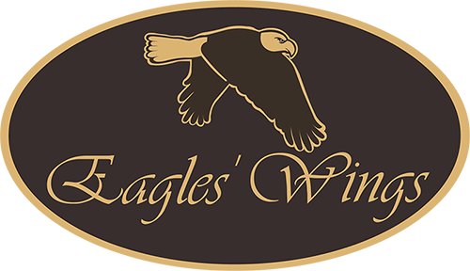
Understanding HCBS Requirement: Access to Food

Name: ______________________________ Date: _________________

- T F People have choices of when, where and with whom they would like to eat.
- T F The kitchen and food storage areas are accessible to me. Kitchen cabinets and
refrigerators are not locked or “off-limits.”
- T F I can get and have snacks outside of mealtimes if I want to.
- T F Staff may not limit what I eat or drink due to their personal beliefs.
- T F I can eat when I want to and sit where and with whom I want to.
6. T F Do not limit a person’s access to food unless there is an identified and
documented risk to the person’s health or safety that requires rights
modification.

Score: ___________

